MicroGoal
Ideation Phase
Brainstorm & Idea Prioritization

Date | 09 March 2026
Team ID | SWTID-2026-7273
Project Name | MicroGoal
Maximum Marks | 4 Marks

Brainstorm & Idea Prioritization Template
Step-1: Team Gathering, Collaboration and Select the Problem Statement:-

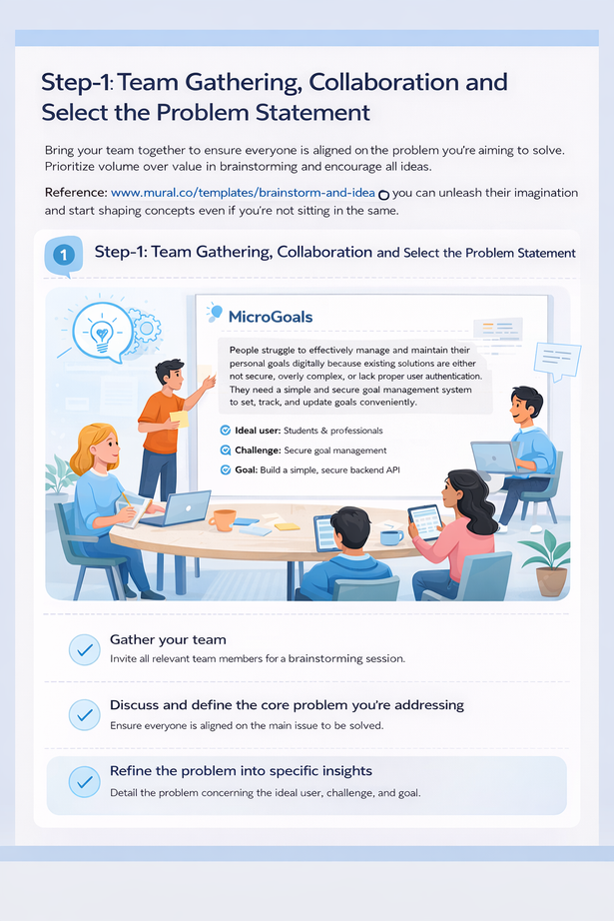

Step-2: Brainstorm, Idea Listing and Grouping:-

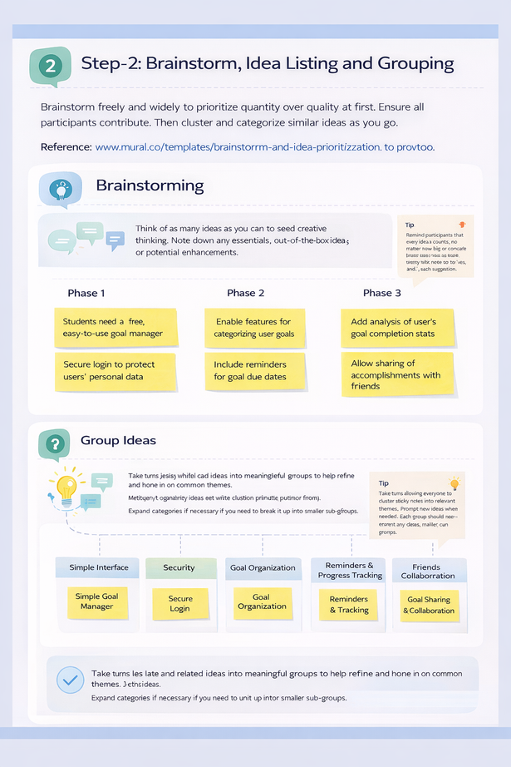

Step-3: Idea Prioritization:-

